Instructions for filling in the Learning Feedback Survey Questionnaire
Access NCNU Administration System (https://www.doc.ncnu.edu.tw/ncnu/) → Enter student number and password → Select (click) Learning Feedback Survey Questionnaire
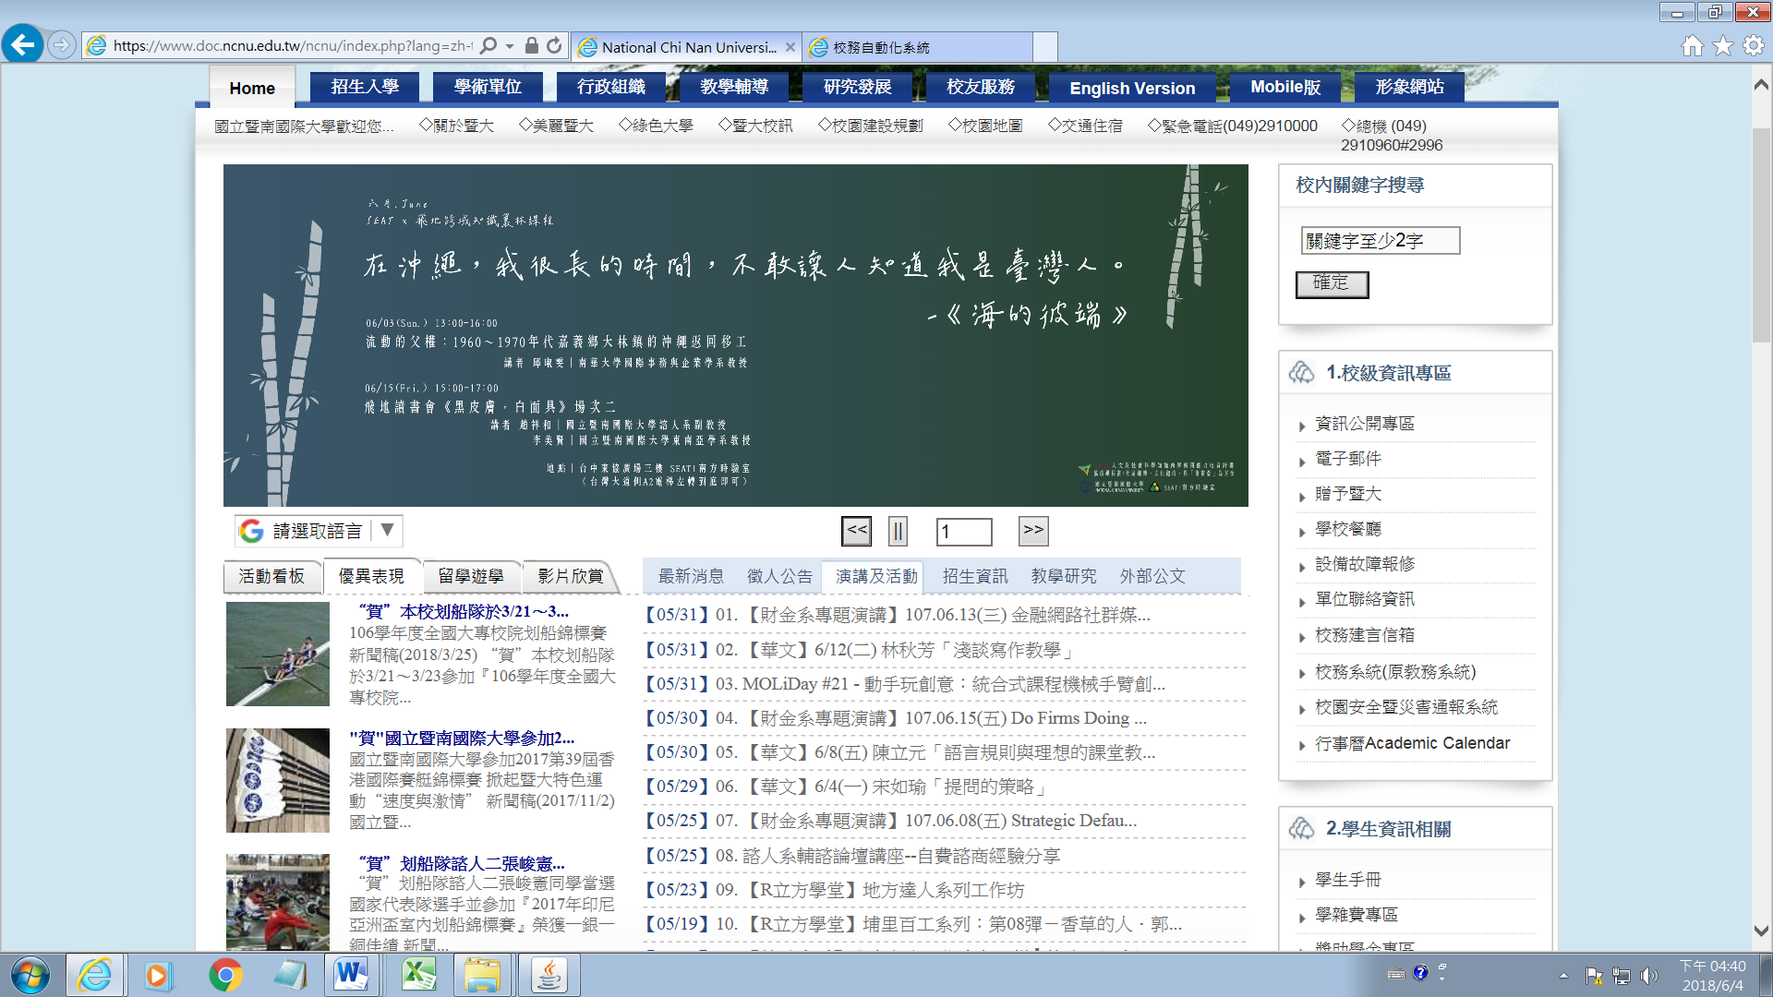
NCNU Administration System

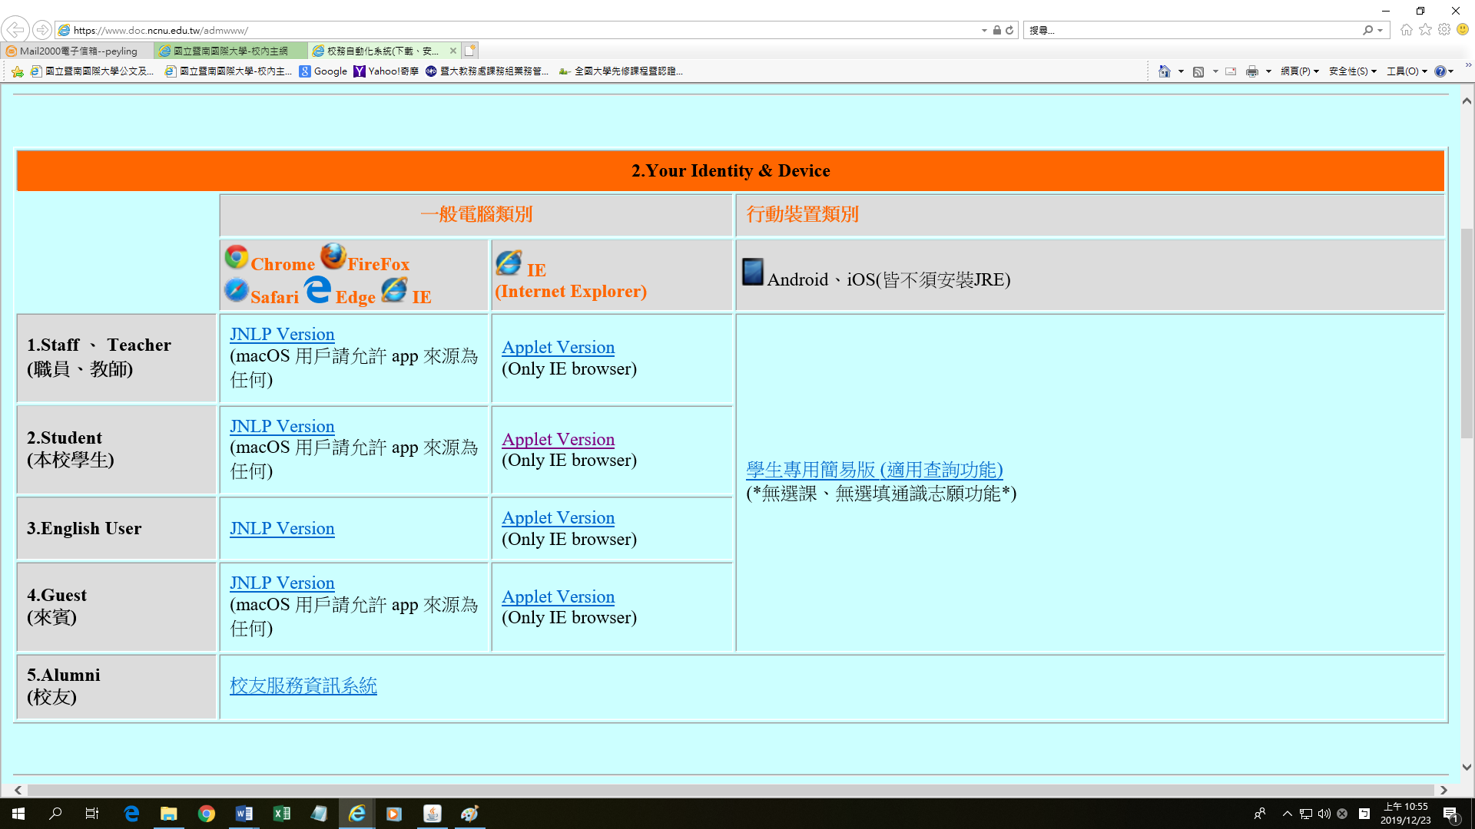
Select (click)

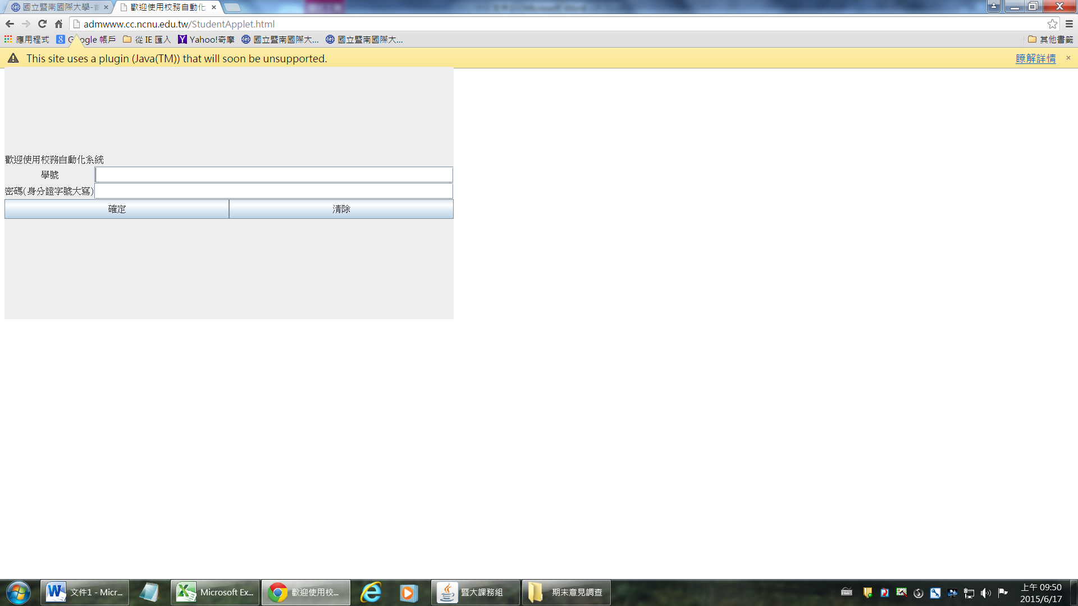
Student number
password
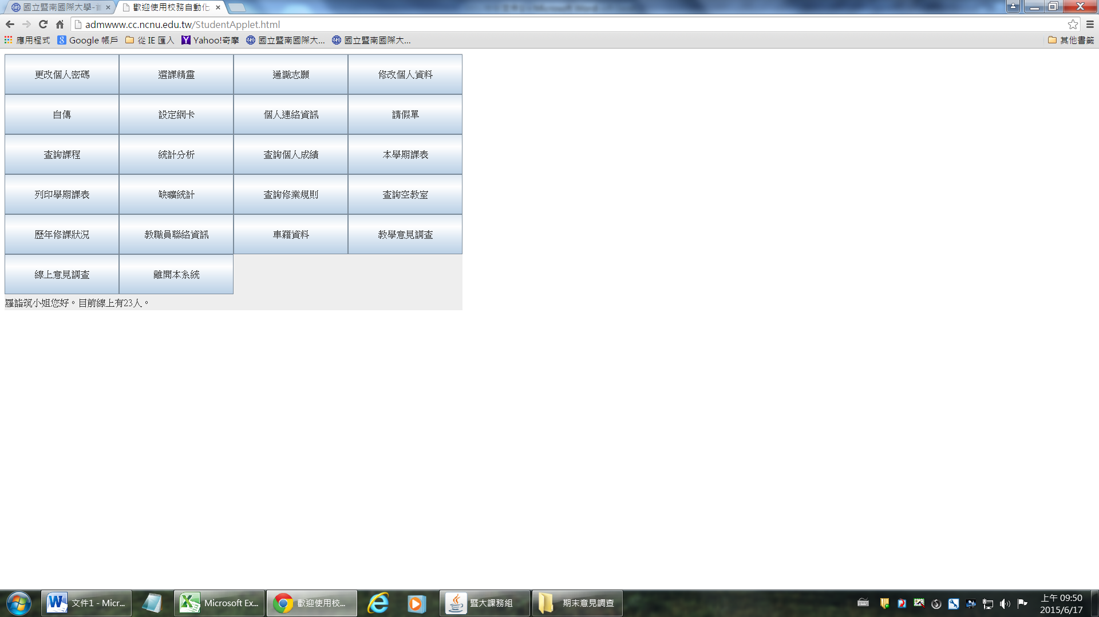
Learning Feedback Survey Questionnaire

